**AJAY KUMAR GARG ENGINEERING COLLEGE, GHAZIABAD**



Session: 2020-21

Project Report on:

**Joy of Programming using Python**

Submitted for- Summer Internship Program

Topic:

**YouTube Downloader**

**Under the Guidance of:** Mrs.Pratima Singh & Mr.Binayak Parashar

**Submitted by**: SUMIT KHARE(1900270110053)

SUMIT DIWAKER (1900270110052)

VAIBHAV CHAUHAN(1900270110062)

SURYA PRATAP SINGH(1900270110054)

**INDEX**

|  |  |
| --- | --- |
| 1. | Object |
| 2. | Abstract |
| 3. | Requirements |
| 4. | Sample Input Format |
| 5. | Sample Output Format |
| 6. | Test Cases |
| 7. | Bibliography |

**YouTube Downloader**

Object:

To create a working code for an efficient YouTube downloader using Python programming language.

Abstract:

More than a Billion people watch YouTube every month. Sometimes there are videos we like to download permanently. YouTube doesn’t give us that option. The YouTube downloader code uses a simple UI and has the ability to download YouTube videos in different formats and video quality easily. It gives us the benefit of downloading Mp4 videos with a choice of different resolutions.

And in order to download a video with python, the program needs to access the source streaming that video. So, it will be using a package called pytube3 to access videos from links and download them.

Requirements:

* Python (version 3 and above)
* Atomic Text Editor
* pytube (lightweight, dependency-free Python library and command-line utility)

So, in this project we will be giving user an option to choose the directory in which the user wants the video to be downloaded.

Also, we will be giving four resolution options to choose for the quality of the downloaded video.

1. 360p
2. 480p
3. 720p
4. 1080p

As the video is downloaded, the user will be prompted for a completion message and the directory where the video is saved.

**Solution**

First of all, make sure that pytube is installed in your system by using the command ‘**pip install pytube3**’ in your command prompt.

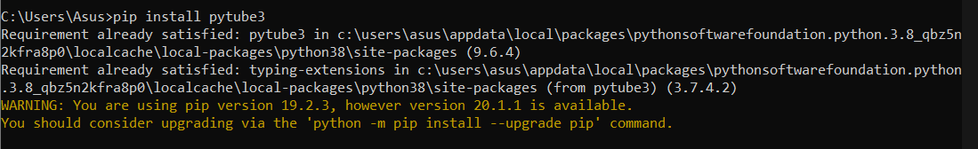

**After that, in any IDE start writing the code to download videos.**

**Code**

1. 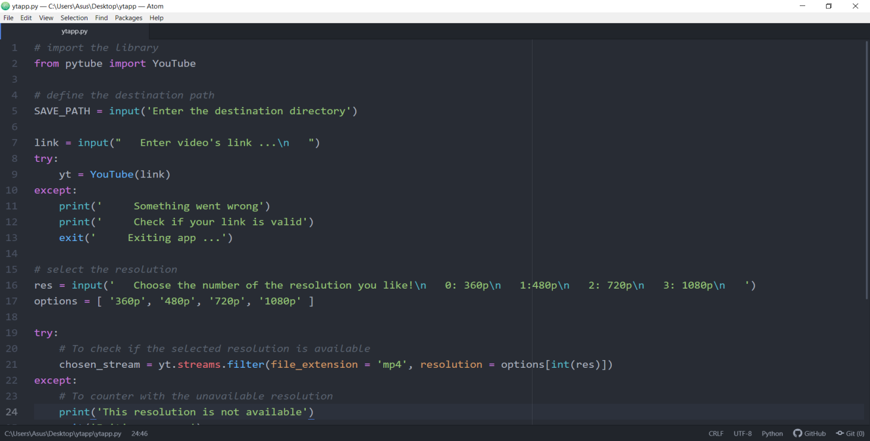Lines 1-24:
2. Lines 24-35:

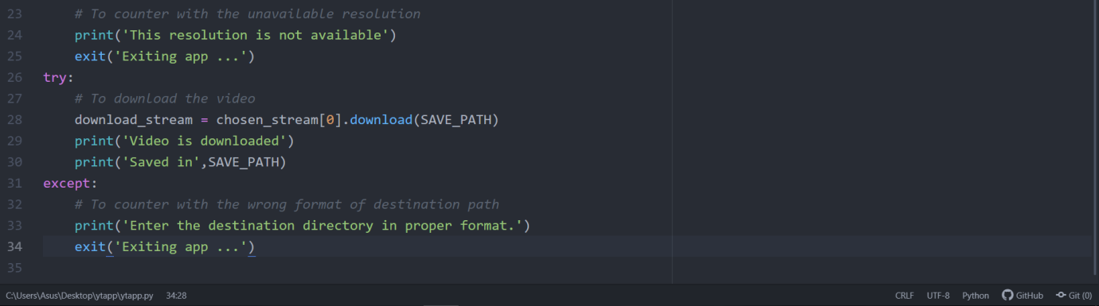

**Input Format**

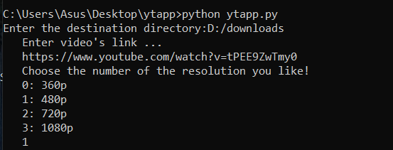Enter the directory in which you want to save the video, link of the video you want to download and the resolution in which you want the video to be downloaded.

**Output Format**

Your video will be downloaded in the selected directory.

And the output will be:

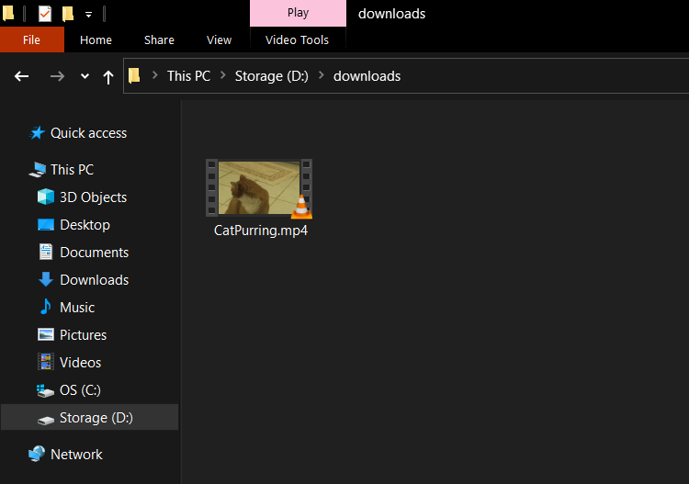



**Test Cases**

1. 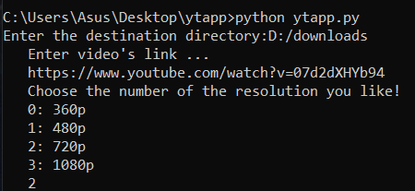Test Case 1 Input:
2. 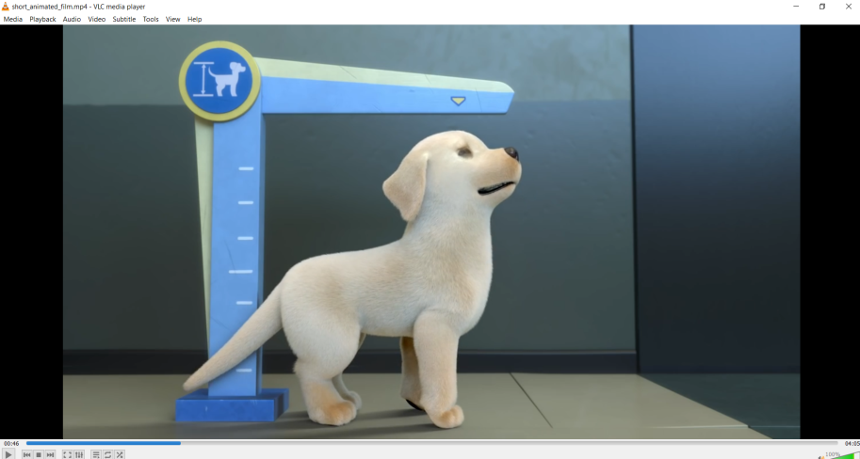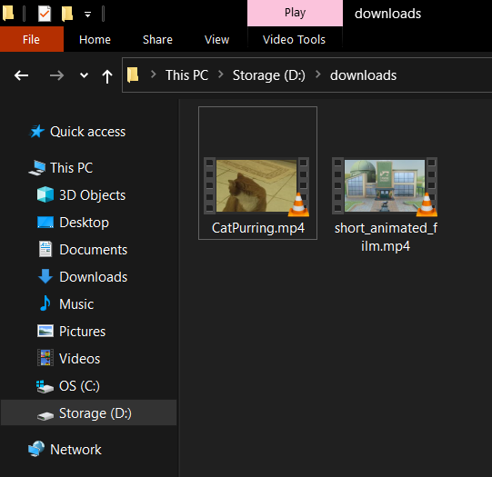Test Case 1 Output:
3. 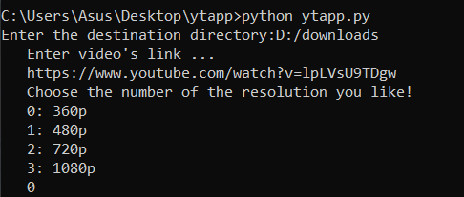Test Case 2 Input:

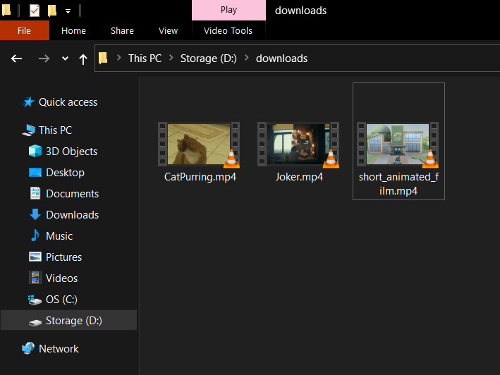 2. Test Case 2 Output:

1. 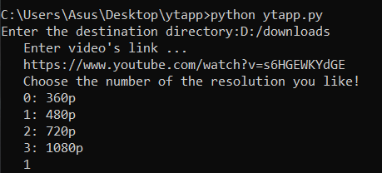Test Case 3 Input:

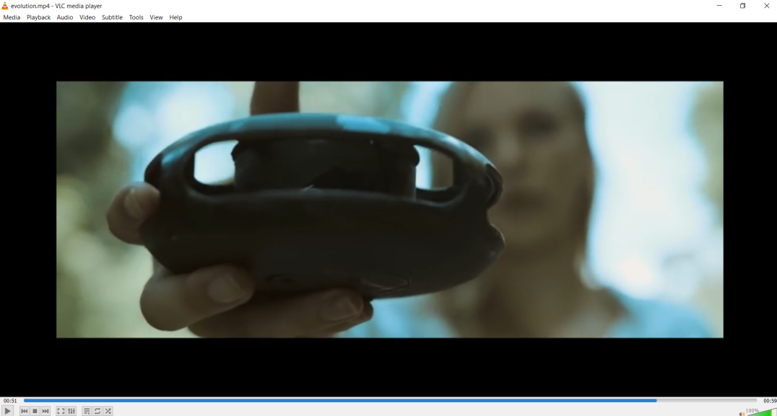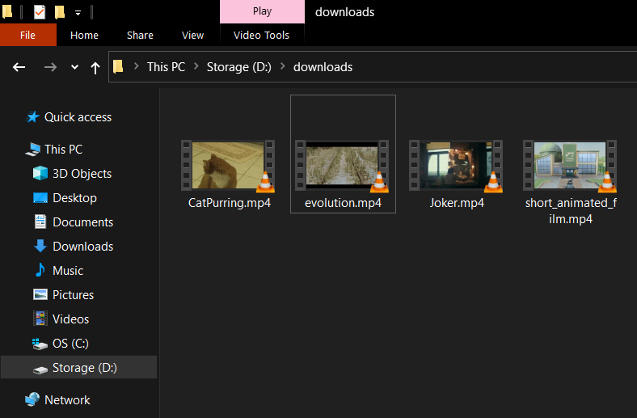 3. Test Case 3 Output:

1. 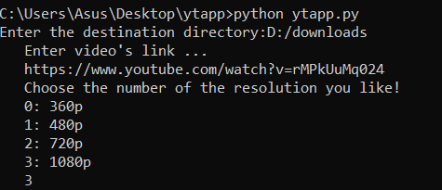Test Case 4 Input:

4. Test Case 4 Output:

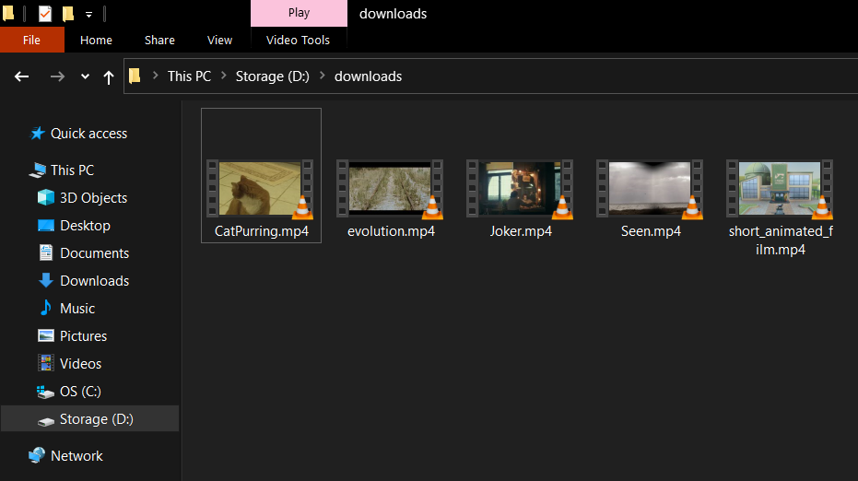



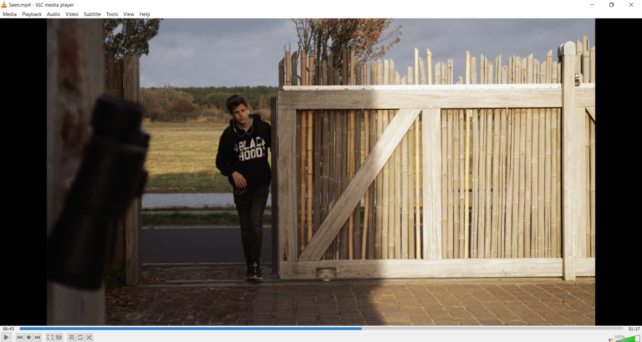

**Bibliography**

* <https://www.geeksforgeeks.org/pytube-python-library-download-youtube-videos/>
* <https://stackoverflow.com/questions/40713268/download-youtube-video-using-python-to-a-certain-directory>